Finance report – 12th May 2026
Item 14 Financial and Governance Matters: – RFO
- Payment approval

- Budget summary – page 3
- Bank reconciliation – page 4
- Circulation and approval of end of year bank reconciliation 2025-26 – page 5
- To receive the Annual Internal Audit 2025-26 report and agree any actions.

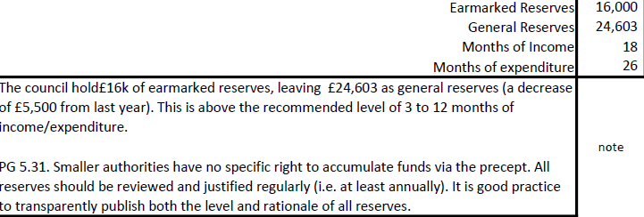
Two points to note:
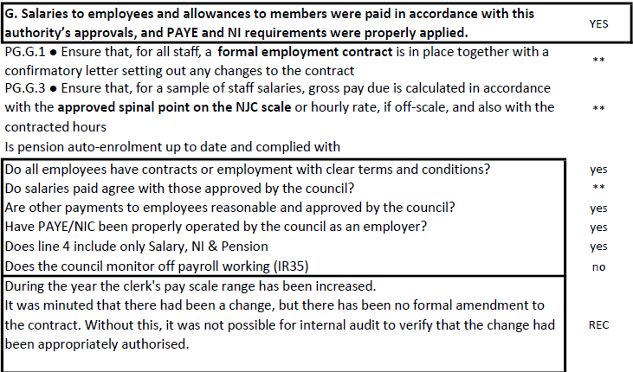

- Approval of Annual Governance Statement 2025-26
- Approve Accounting Statements 2025-26
- Approve Certificate of Exemption 2025-26
- To approve the commencement date for the exercise of public rights, notice date 2nd June 2026, commencing from 3rd June 2026 to 14th July 2026.

Bank reconciliation as at 12:20 5th May 2026

Balance as per statement £21,767.19

Less payments to be made £0

Balance as per cashbook £27,767.19

