Minutes of the parish council meeting held on Tuesday 10th March 2026 at 7.00pm at
Bradley Village Hall, Church Lane, Bradley ST18 9DY
ATTENDEES
Cllr P Oxley (Chair) | Cllr M Rossi (Vice Chair) | Cllr T Luck | Cllr R Turner
Cllr M Yarwood | Cllr M Newman | Cllr L Phillips | Nikola Evans (Clerk)
Cllr J Rose – SBC & SCC | MOP - 1

1 | Declaration of Interests on agenda items and any dispensations grated
 | None received
2 | To receive Apologies
 | Cllr Yarwood did not attend – no apologies received
3 | Minutes of the last meeting – 13th January 2026
 | Approved as a true record by all that attended
4 | To adjourn parish council meeting to allow for public participation
 | 19:05
5 | Public participation - Members of the public are invited to address the Council on any item on the agenda, for up to 5 minutes each, with the item lasting a maximum of 20 minutes.
 | MOP spoke about encouraging The Bradley Trust to answer questions about land assets
6 | To receive Stafford Borough Councillor report
 | None
7 | To receive Staffordshire County Councillor report
 | None
8 | To close the meeting to members of the public and continue with parish council business
 | 19:15
9 | Consideration of new planning applications
 | None to consider
10 | Finance
10.1 | Payment approval

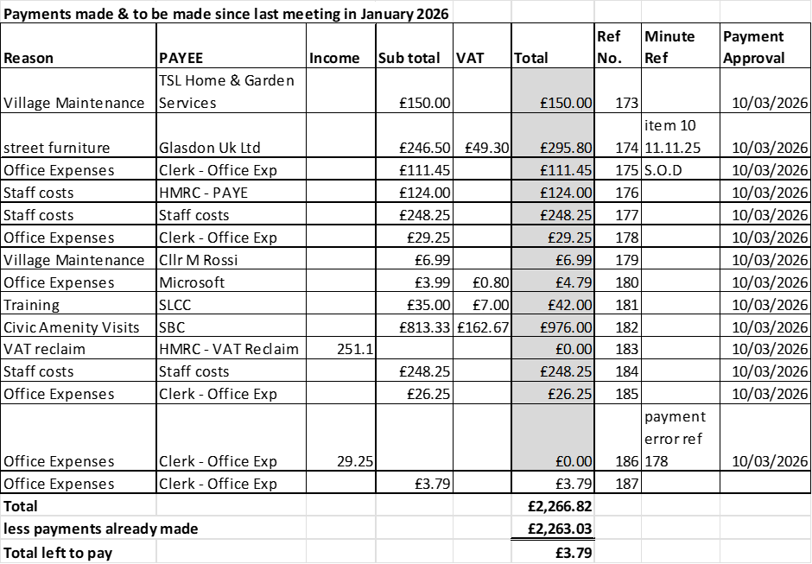

APPROVED
10.2 | To consider adding a new column onto the payments approval sheet which provides a brief justification for the expenditure.
 | RESOLVED for the clerk to expand on reasons for expenditure on payment approval report. Clerk to action
10.3 | Budget summary
 | APPROVED
10.4 | Bank reconciliation
 | APPROVED
10.5 | To approve retrospective expenditure for the cost of subscribing to a PO Box to comply with AGAR Assertion 10 (Digital & Data Compliance) requirements, principles of good governance, data protection, continuity, and professionalism expected of public bodies. Cost split between clerk’s other parish councils, £111.45 each per annum
 | APPROVED – with note to review next year
11 | To consider and adopt the following policies for new AGAR Assertion 10 (Digital & Data Compliance) requirements  - Data Protection Policy  - IT & Digital Communications Policy  - Social media Policy
 | APPROVED and adopted
12 | To consider and adopt the following processes and policies.  - Councillor and Officer Roles & Responsibilities Policy  - Meeting summary Process
 | APPROVED and adopted
13 | To discuss and consider proposal for litter picking initiatives – Cllr Philips
 | No proposals presented
14 | To discuss and consider next steps in Rural Housing Project.  - Vote to moving forward with the project  - Creation of task and finish group (No delegated authority, decisions must be brought back to the full council for resolution)

RESOLVED to move forward with the project. Working Group formed:

Cllr Turner – Lead alongside the Clerk, Cllr Newman and Cllr Rossi. Clerk will make the necessary arrangements for the next steps.
15 | To discuss and agree the parish council’s response to Local Government Reorganisation consultation, deadline 23:59 on 26th March 2026
 | RESOLVED to support East West proposal, clerk to submit parish council’s response on local government reorganisation survey.
16 | To resolve to move forward with supporting Atlas Tower Group Ltd with the installation of a new mobile mast.
 | Lack of response to online survey, RESOLVED for clerk to arrange paper survey, cllrs to visit in person around the village.
17 | Councillor/clerks Reports – Information only
 | Cllr Newman spoke about the open space on Malthouse Lane and Elm Drive. Can the tree stumps be removed and can the residents plant a tree. Clerk will ask Stafford Borough Council.
18 | Next meeting Date –  - REMINDER – 8th April 2026 Annual Parish Meeting 2026, from 7pm at Bradley Village Hall  - 12th May 2026 – Annual Parish Council Meeting
 | APPROVED
19 | Due to the unavailability of the Chairman on the original approved date, Cllr Oxley proposes to consider moving the approved date of the full council meeting from 8th September 2026 to Tuesday 15th September 2026, and to resolve whether the meeting should proceed on the originally approved date of 8th September 2026 with the Vice-Chairman presiding.
 | RESOLVED to move the meeting to 15th September 2026, clerk to action.
20 | Future meeting dates  - 14th July 2026  - 15th September 2026  - 10th November 2026  - 12th January 2027  - 9th March 2027  - 11th May 2027 – Annual Parish Council Meeting  - Between 1st March – 1st June 2027 Date TBC.
 | APPROVED
21 | Meeting Closed
 | 20:24

For the purpose of these minutes SCC refers to Staffordshire County Council, SBC refers to Stafford Borough Council and MOP refers to Members of the public.

