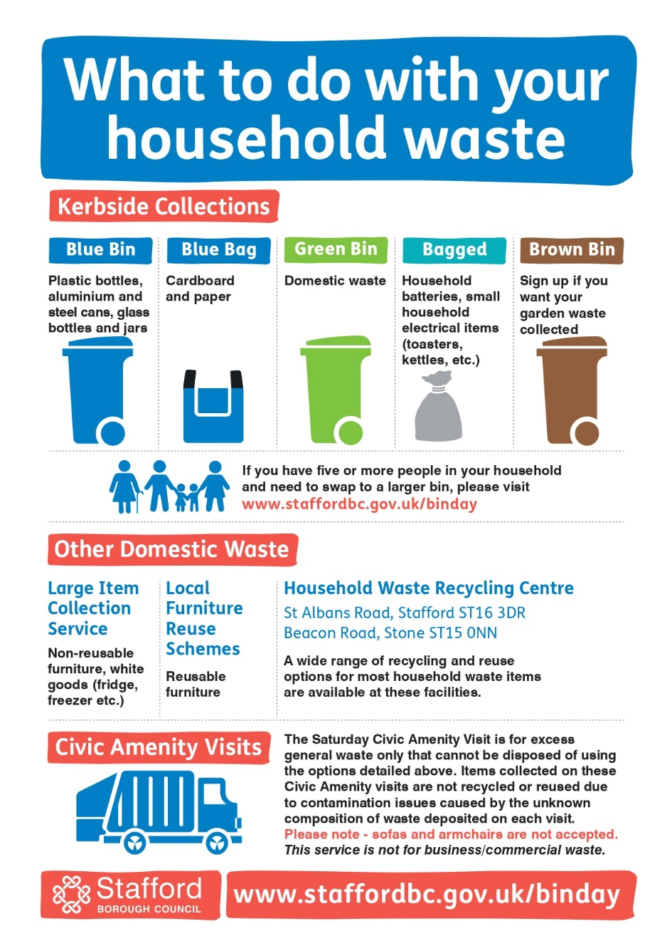

Site: Bradley Village Hall Car Park
Dates: 14th March, 20th June, 12th September and 12th December
Times: 9.00 - 10.00
Site: Almshouse Croft, Bradley
Dates: 14th March, 20th June, 12th September and 12th December
Times: 10.15 - 11.15
Please be aware that, due to a change in legislation, we do not accept sofas or armchairs at the Civic Amenity Visits. This is due to legislation around Persistent Organic Pollutants (POPs) which are found in soft furnishings, these items cannot be crushed (as they would be in the collection vehicle) and need to be collected separately either by arrangement with Stafford Borough Council or taken to designated containers at the Household Waste Recycling Centres in Stafford and Stone.

