Minutes of the parish council meeting held on Tuesday 13th January 2026 at 7.00pm at
Bradley Village Hall, Church Lane, Bradley ST18 9DY
ATTENDEES
Cllr P Oxley (Chair) | Cllr M Rossi (Vice Chair) | Cllr T Luck | Cllr R Turner
Cllr M Yarwood | Cllr M Newman | Cllr L Phillips | Nikola Evans (Clerk)
Cllr J Rose – SBC & SCC | MOP - 0

1 | Declaration of Interests on agenda items and any dispensations grated
 | None received
2 | To receive Apologies
 | None received, Cllr Turner and Cllr Yarwood did not attend
3 | Minutes of the last meeting – 11th November 2025
 | Approved as a true record by all that attended
4 | To adjourn parish council meeting to allow for public participation
4.1 | Public participation - Members of the public are invited to address the Council on any item on the agenda, for up to 5 minutes each, with the item lasting a maximum of 20 minutes.
 | None attended
4.2 | Stafford Borough Councillor report

Cllr Rose reported on the following:
- Highways survey – Deadline is 1st May; he welcomes any information residents wish to report.
- Empty homes, Cllr Rose and the parish council received an update from Housing Standards and Environmental Protection Manager, reporting no action can be taken at present.
- Grit bins, Cllr Rose asked for locations that were not covered.
- The Planning Enforcement Policy is currently being updated, hopefully this will help with enforcement of some of the more complicated cases.
4.3 | Staffordshire County Councillor report
 | See item 4.2
5 | Consideration of new planning applications
 | None
6 | To receive reports on any new footpath, village maintenance or highways issues
- Update requested on replacement trees in Malthouse Lane, clerk to action
- Levedale Rd – Road surface is extremely bad, potholes and broken manhole cover. Cllr Philips will report but with the number of issues on that road reporting using the highways system is very onerous. Reported to Cllr Rose to feedback to SCC.
7 | Finance – RFO
7.1 | Payment approval

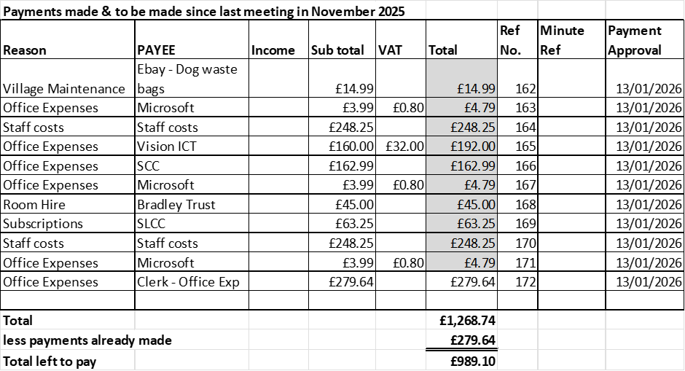

APROVED
7.2 | Budget summary
 | APPROVED
7.3 | Bank reconciliation
 | APPROVED
7.4 | To agree precept request for 2026-27
 | Approved to request £15,250 resulting in no increase in the parish council’s portion of the council tax.
7.5 | Consider earmarking further £4,000 for next elections in 2027 making a total of £10,000. Possibility of us having to fund all costs due to local government reorganisation, no longer share costs with Stafford Borough Council elections.
 | APPROVED
8 | Consider moving forward with mobile connectivity project. Installation of a new mast to boost mobile phone coverage.
 | Whilst the parish council are not against it, they will require public consultation before agreeing to support the project. Clerk to advise project planners.
9 | To discuss correspondence from Cllr Mark Deaville (Staffordshire Moorlands District Council) regarding LGR and consider endorsing his letter. Deadline 21st January 2026
 | Noted, no further action
10 | Councillor/clerks Reports – Information only
 | - Cllr Philips is looking into an exchange of items to coincide with the civic amenities
11 | Next Agenda items
- Litter picking initiatives
- Update on Rural Housing Project
12 | To agree date of next meeting –  - 10th March 2026, from 7pm at Bradley Village Hall  Future meeting dates  - April Date TBA – Annual Public Meeting, provisionally 14th or 21st April, clerk to organise.  - 12th May 2026 – Annual Parish Council Meeting  - 14th July 2026  - 8th September 2026  - 10th November 2026
 | APPROVED
13 | Meeting Closed
 | 20:10

For the purpose of these minutes SCC refers to Staffordshire County Council, SBC refers to Stafford Borough Council and MOP refers to Members of the public.
Local Government Reorganisation

