Minutes of the parish council meeting held on Tuesday 9th September 2025 at 7.00pm at
Bradley Village Hall, Church Lane, Bradley ST18 9DY
ATTENDEES
Cllr P Oxley (Chair) | Cllr M Rossi (Vice Chair) | Cllr T Luck | Cllr R Turner
Cllr M Yarwood | Cllr M Newman | Cllr L Phillips | Nikola Evans (Clerk)
Cllr J Rose – SBC & SCC | MOP

1 | Declaration of Interests on agenda items and any dispensations grated
 | None received
2 | To receive Apologies
 | None
3 | Minutes of the last meeting – 9th September 2025
 | Approved as a true record by all that attended
4 | To adjourn parish council meeting to allow for public participation
4.1 | Public participation - Members of the public are invited to address the Council on any issue over which it has power for up to 5 minutes each, with the item lasting a maximum of 20 minutes.
 | None attended
4.2 | Stafford Borough Councillor
 | None received
4.3 | Staffordshire County Councillor
 | None received
5 | To receive clerks report on any actions from previous meeting
Potential Speed Indication Device project – Holly Lane. Highways are currently in the process of reviewing the SID’s devices policy. No further information available.
Affordable Rural Housing Project - No further updates at this time, awaiting information on next steps.
6 | To receive report on outstanding planning applications
Application Number | Site Address | Proposed Development | Action
24/38841/FUL | Land Opposite Greenhouse Mitton Road Bradley Stafford Staffordshire | Change of use of land for the re-siting of approved self-storage containers to be used by enterprise on site and private business uses, addition of solar panels and new access | ALLOWED
24/39639/FUL | Land At Forge Rise Bradley Stafford Staffordshire | Conversion of detached garage to residential dwelling | Awaiting decision

7 | Consideration of new planning applications
7.1 | 25/41071/FUL at Coppice Farm Lapley Road Church Eaton - described as Removal of Condition 4 on application 23/37327/FUL
 | No objections
8 | To receive reports on any new footpath, village maintenance or highways issues

Update on Mitton Road site, protruding wall. - No further information available, clerk to chase

Empty Homes – Cllr J Rose reported asking if SBC could pursue either an EDMO or Housing Act 1985, s17 to get the properties back into ownership and being used. SBC advised, neither option would be something they would currently explore. Cllr M Newman along with the clerk will keep investigating.

Severn Trent road works – Concerns raised for Bradley Lane road closure, Cllr Rossi along with the clerk will consult with highways and Severn Trent to keep the road open.
9 | Finance – RFO
9.1 | Payment approval - APPROVED
 | 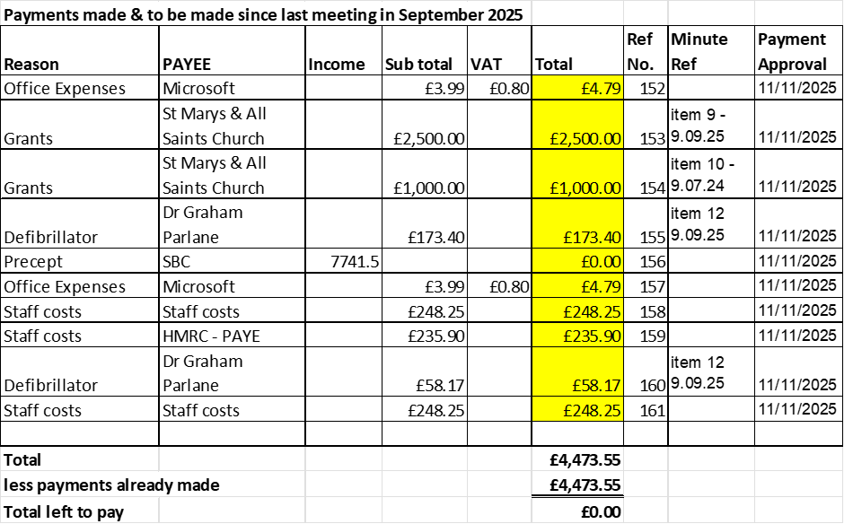
9.2 | Budget summary
 | APPROVED
9.3 | Bank reconciliation
 | APPROVED
9.4 | To approve 2026-27 draft Budget
 | APPROVED
9.5 | Consider earmarking £6,000 for the installation of two Speed indication devices when permitted.
 | APPROVED
10 | To consider new dog waste bin, bottom of smithy lane and wells lane. Cllr Luck
 | RESOLVED: to install another dog waste bin on the other side of the pole, Cllr luck will send link of bin for clerk to purchase. TSL Home & Garden Services Ltd, will install.
11 | To consider and approve 2026 civic amenity visits

RESOLVED:
1 hour at a single location £122.00
Village Hall x 4 = £488
Almshouse x 4 = £488
Total £976 + VAT
Clerk to action.
12 | To consider proposal for updated defib training
 | RESOLVED: to go ahead, Cllr Phillips will lead with the organisation alongside the clerk.
13 | Councillor Information
 | Mobile connectivity, involvement in locations for a mast. APPROVED, clerk will arrange a meeting. Cllr Rossi, Cllr Newman along with the clerk.
13.1 | Next Agenda items
 | None
14 | To agree date of next meeting –  - 13th January 2026, from 7pm at Bradley Village Hall  Future meeting dates  - 10th March 2026  - April Date TBA – Annual Public Meeting  - 12th May 2026 – Annual Parish Council Meeting  - 14th July 2026  - 8th September 2026  - 10th November 2026
 | All meeting dates APPROVED
15 | Meeting Closed
 | 19:55

For the purpose of these minutes SCC refers to Staffordshire County Council, SBC refers to Stafford Borough Council and MOP refers to Members of the public.
Empty Dwelling Management Order

