Minutes of the parish council meeting held on Tuesday 9th July 2024 at 7.00pm at
Bradley Village Hall, Church Lane, Bradley ST18 9DY
Attendees
Cllr P Oxley (Chairman) Cllr M Newman Cllr R Turner Cllr L Phillips
Cllr T Luck Cllr M Yarwood Clerk – Nikola Evans
1 x MOP
1 | Declaration of Interests on agenda items and any dispensations grated
 | None received
2 | To receive Apologies
 | Cllr M Rossi – Holiday – Accepted as valid reason
3 | Minutes of the last meeting – 8th July 2025
 | Approved as a true record by all that attended
4 | To adjourn parish council meeting to allow for public participation  - Public participation – (Members of the public are invited to address the Council on any issue over which it has power for up to 5 minutes each, with the item lasting a maximum of 20 minutes).  MOP commented on agenda publication.  - Stafford Borough Councillor – None attended  - Staffordshire County Councillor – None attended
5 | To receive an update of any actions from previous meeting
a | Update on Mitton Road site, protruding wall.  No further information available, clerk to chase
b | Update on SID’s potential future project.  No further information available, awaiting instructions from SCC, highways on possible locations, clerk to chase and also investigate private contractors to research possible locations too.
c | Affordable Rural Housing survey results.  A Housing need survey questionnaire and covering letter was delivered to 220 residential properties in the parish via Royal Mail. A total of 17 responses were received, giving an overall response rate of 8%.  59% of respondents require an alternative form of accommodation to that which they currently reside in. This need can be met by providing affordable homes catering to their specific requirements or by open market developments which are typically larger in scale.  Bungalows have been identified as a desired form of accommodation and there is a lack of these within the parish. With a 25% need, this would indicate at least 4 affordable bungalows (either shared ownership, rented, discounted market sale or private) required, but is dependent on green belt/suitable land becoming available for acquisition.  Home ownership in the parish is high, with the majority owning their home, either outright or with a mortgage. Currently, no households which responded, rent from a Housing Association and nobody rents within the private rented sector. This could indicate that smaller, potentially more affordable homes are therefore limited in supply.  Clerk to investigate next steps and report back.
6 | To receive report on outstanding planning applications
Application Number | Site Address | Proposed Development | Action
24/38841/FUL | Land Opposite Greenhouse Mitton Road Bradley Stafford Staffordshire | Change of use of land for the re-siting of approved self-storage containers to be used by enterprise on site and private business uses, addition of solar panels and new access | Awaiting decision
24/39639/FUL | Land At Forge Rise Bradley Stafford Staffordshire | Conversion of detached garage to residential dwelling | Awaiting decision
25/40696/HOU | Land at High Lawn, Bury Ring, Billington | Proposed rear single-story extension. | ALLOWED

7 | Consideration of new planning applications  - 24/38841/FUL (Land Opposite Greenhouse Mitton Road Bradley Stafford Staffordshire) Change of use of land for the re-siting of approved self-storage containers to be used by enterprise on site and private business uses, addition of solar panels and new access
 | No objections only concern raised for the destruction of trees, can these be replanted elsewhere? Clerk to submit concerns.
8 | To receive reports on any new footpath, village maintenance or highways issues
 | None received
9 | To consider grant request from St Mary’s and All Saints Church
 | Motion to move agenda item to be discussed before item 4. Approved to award £2,500 towards the cost of repairing the wall. Clerk to action
10 | Finance – RFO  - Payment approval – Finance report circulated before the meeting.  - Budget summary – Finance report circulated before the meeting.  - Bank reconciliation – Finance report circulated before the meeting.

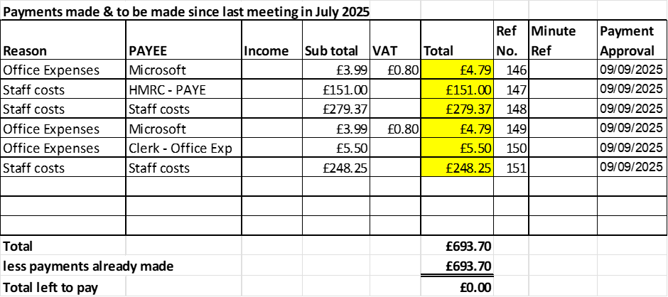

Items 10 a-c all approved, clerk to action
11 | To consider new dog waste bin, bottom of smithy lane and wells lane. Cllr Luck & Clerk
 | Defer to next meeting, no further information available
12 | To consider request for funding towards defibrillator costs.
 | Approved to pay half towards the cost of the battery (£173.40) and agree to fund half towards the cost of new pads upon receipt of a valid invoice.
13 | Councillor Information and items for the next Agenda  Cllrs are invited to give reports on parish issues which do not require a resolution.

Cllr Newman reported on the following:
- Cllr J Rose (SCC) is proposing a countywide policy to restrict traffic in rural villages to 20mph.
- 2 x bungalows on Malthouse Lane remain empty and are causing concern for residents, clerk advised properties have already been reported to Empty Homes team at Stafford Borough Council.
- 2 x trees have been removed from Malthouse Lane; clerk advised one tree was diseased and the other was leaning, potentially could cause damage to a property.
14 | To agree date of next meeting –  - 12th November 2025, from 7pm at Bradley Village Hall  Future meeting dates  - 13th January 2026
15 | Meeting Closed
 | 20:00

For the purpose of these minutes, MOP refers to member of the public.
For the purpose of these minutes SCC refers to Staffordshire County Council.

