**Finance report 9th September 2025**

Item 10 **Finance – RFO**

1. **Payment approval**



1. **Budget summary – page 2**
2. **Bank reconciliation – page 3**



**Bank reconciliation – 9th September 2025**

Balance as per statement £15201.68

Less payment £0

Balance as per cashbook £15201.68



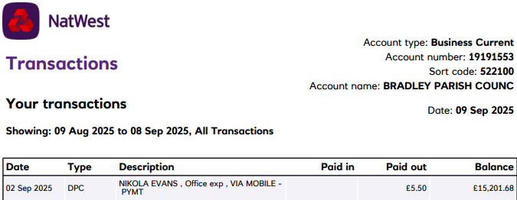

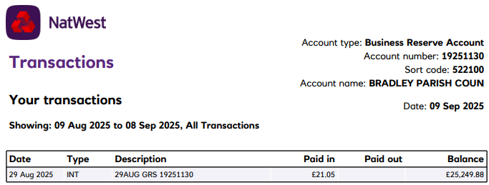

|  |  |  |  |
| --- | --- | --- | --- |
| Current Account | £15,201.68 | **Earmarked funds** |  |
| Reserves account | £25,249.88 | Elections | £6,000.00 |
| Less earmarked funds | £6,000.00 |  |  |
| **Total** | £34,451.56 |  |  |

|  |  |  |  |  |
| --- | --- | --- | --- | --- |
|  |  |  |  |  |
| Signed ____________________________ | | | Date _______________________ | |
|  |  |  |  |  |
|  |  |  |  |  |
| Signed ____________________________ | | | Date _______________________ | |
|  |  |  |  |  |