Minutes of the parish council meeting held on
Tuesday 11th March 2025 at 7.00pm at
Bradley Village Hall, Church Lane, Bradley ST18 9DY

Attendees
Cllr P Oxley (Chairman) Cllr M Newman Cllr T Luck Cllr R Turner
Cllr L Phillips Cllr M Rossi (Vice Chairman)
Nikola Evans - Clerk

1 x MOP

1 | Declaration of Interests on agenda items
 | None received
2 | To receive Apologies
 | None received, Cllr M Yarwood did not attend this meeting
3 | Minutes of the last meeting – 14th January 2025
 | Proposed Cllr T Luck, 2nd Cllr M Newman – approved as a true record
4 | To adjourn parish council meeting to allow for public participation
- Public participation - MOP asked the following question to be answered at the annual public meeting due to take place in May
- Give an explanation of what they are doing to achieve the mission statement
- Have the parish council discussed sustainability issues with The Bradley Trust and what was the outcome.
- Stafford Borough Council – Did not attend
- Staffordshire County Council – Did not attend
5 | Matters arising from previous minutes
- Affordable Rural Housing - RESOLVED to carry out housing needs survey, clerk to organise with Support Stafford
- To revisit the Beautiful Bradley community plan – To be added to the next agenda for consideration, however the parish council needs to be cautious of spending funds until we know more about the local government reorganisation and what extra responsibilities might be imposed on parish councils.
6 | To receive report on outstanding planning applications  Application Number Site Address Proposed Development Action  24/38563/FUL Eaton Brook Farm Woollaston Lane Church Eaton Conversion of an agricultural barn to a residential unit including the alteration and upgrade of fabric to accommodate new windows & doors and the construction of new garage entrance gates and boundary walls and associated patio, outdoor kitchen and amenity spaces. Decided Allowed  24/39280/ANX The Grove Wells Lane Bradley ST18 9EE Conversion of outbuilding to granny annexe with accessible wet room Decided Allowed  24/38841/FUL Land Opposite Greenhouse Mitton Road Bradley Stafford Staffordshire Change of use of land for the re-siting of approved self-storage containers to be used by enterprise on site and private business uses, addition of solar panels and new access Awaiting decision
7 | Consideration of new planning applications
 | - 25/40209/FUL – Land Opposite Greenhouse, Mitton Road, Bradley – proposed development is described as variation of condition 2 and 7 on 21/33853/FUL – extension to existing commercial building. – No objections
8 | To receive reports on any new footpath, village maintenance or highways issues
- Wells Lane Hedge, to consider getting a contractor to trim and tidy the hedge up later in the year.

It has been reported that there is a lot of debris being fly tipped with in the area, RESOLVED to request a price from a local contractor to tidy the area up but not to carry out any cutting of the hedge until the nesting season is over. Clerk to action.

Clerk to also produce a leaflet advising residents of the importance of keeping their hedges tidy and their garden waste to be disposed of in brown bins or local waste disposal sites and not within our green areas.

- Clerk to request an update on the protruding wall at Mitton Lane and to ask Cllr Winnington can help.
- Stiles – ROW walks, some of them are badly damaged and in need of repairing, agreed to get cost to repair and consider doing one at a time. Clerk to action ready for the next meeting, Cllr Phillips will provide photos and locations.
9 | To consider grant requested from St Mary and All Saints Church for financial aid to support the repairs to the church wall near the junction with Barton Lane.
 | The parish council decided with the current local government reorganisation and uncertainty as to the effect it will have on parish councils, they feel they unable help at this time.
10 | Finance – RFO
- Payment approval - APPROVED

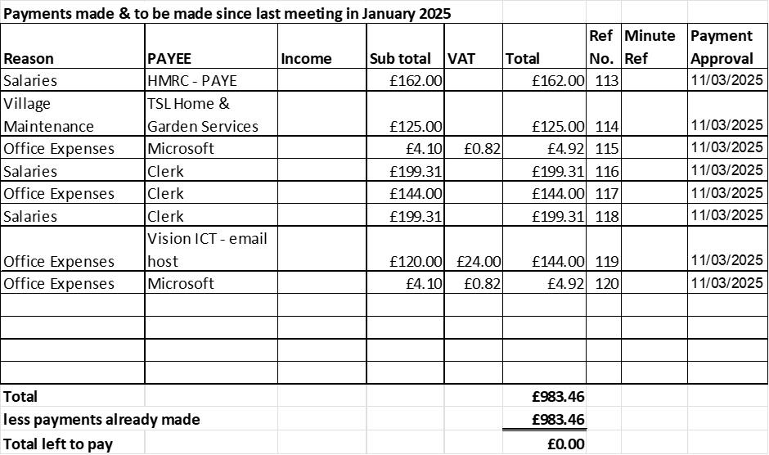
 | - Budget Summary – circulated and approved
 | - Bank Reconciliation – circulated and approved
11 | Councillor Information and items for the next Agenda  Cllrs are invited to give reports on parish issues which do not require a resolution.
- Updates have been carried out to the new community area on the website, next step is to consider what additional content to be included and if we want to invite people to add anything?
- Update on the Red Lion – There has been a dispute with rights of way access, the sale is still ongoing.
- Consideration to revisit the Beautiful Bradley Community plan at the next meeting.
12 | To agree date of next meeting –  - 13th May 2025 – Annual Parish Council Meeting  - 15th May 2025 – Annual Public Meeting from 7:30pm  - 8th July 2025  - 9th September 2025  - 11th November 2025
13 | Meeting Closed – 20:00

