Minutes of the Extraordinary Parish Council meeting held on
Tuesday 6th June 2023 at 7.30pm at
Bradley Village Hall, Church Lane, Bradley ST18 9DY

Attendees

Cllr P Oxley (Chairman) Cllr Martin Rossi (Vice Chairman) Cllr T Luck
Cllr M Newman Cllr M Yarwood Cllr L Phillips
Clerk – Nikola Evans 2 x MOP
1 | To receive Apologies  No apologies were received
2 | Minutes of the last meeting – Annual Parish Council Meeting, 9th May 2023  Approved as a true record by all that attended
3 | Declaration of Interests on agenda items  None received
4 | Finance – RFO  - Payment approval – see finance report – circulated and approved  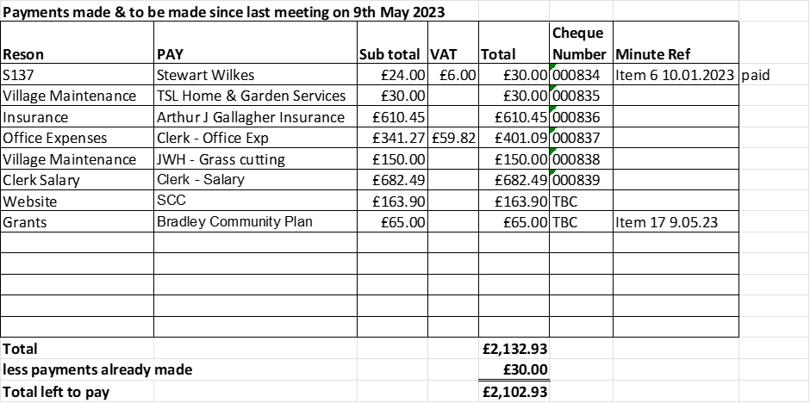  - Budget summary – see finance report – circulated and approved  - Bank reconciliation – see finance report – circulated and approved
5 | To review and discuss Beautiful Bradley Plan  It was agreed by the council to adopt the Beautiful Bradley vision:  ‘With its friendly residents, abundance of wildlife and characterful, individually designed, buildings clustered around its 13th century grade I listed church, the Parish Council of Bradley will use its best endeavours to ensure that the village of Bradley and its wider parish, will retain its quaint character, safe environment, and community spirit, to become a more sustainable and beautiful place to live, work and play, better connected to its surrounding villages and their communities, whilst remaining small and intimate’  Proposed – Cllr M Rossi  Second: Cllr M Yarwood  It was agreed the council would adopt the strategic aim to help address the climate challenge:  ‘In seeking to ensure that Bradley will become a more sustainable place to live, work and play, Bradley Parish Council will explore ways it can show leadership amongst its residents and businesses of ways it can help to address the climate challenge at a community level in both the decisions and actions it takes and the encouragement of residents in the decisions they make, individually and collectively, to reduce the community’s overall carbon footprint.’  Proposed: Cllr L Phillips  Second: Cllr M Rossi  Both statements will be added to the council’s website - https://www.bradleypc.co.uk/  A MOP stated they were please the council had adopted the vision and strategic statements  The council proceeded to review the proposed action plan (this can also be viewed on our website https://www.bradleypc.co.uk/news-article/bradley-community-plan/, and will be updated after each action has been resolved) to decide, how, if and when, it would be possible to move forward with various matters.
6 | Councillor Information and items for the next Agenda  Cllrs are invited to give reports on parish issues which do not require a resolution.  Item for next agenda:  - Newsletter to promote better waste management.  - Consider installing more bins around the village.
7 | To agree date of next meeting – 11th July 2023 @ Bradley Village Hall, from 7.30pm  - Future meeting dates – 12th September 2023 & 14th November 2023
8 | Meeting Closed – 21.25pm

