Walk 8

1. Staffs County Council map of area relating to this walk.


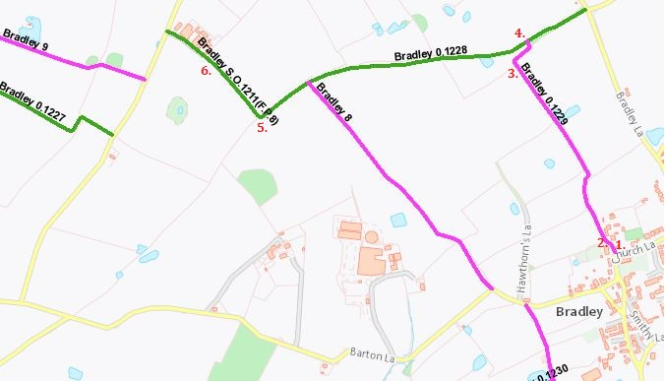

2. The relevant Google Earth image on which is superimposed the outline of this walk.

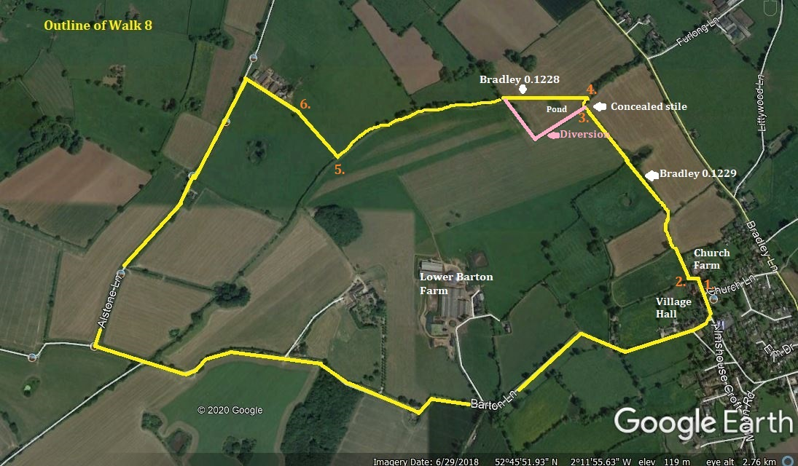

Walk 8 is roughly 3^{1/2} miles in length and takes approximately one hour and a half. Apart from an upward slope at the end of Barton Lane this walk is flat.
Note: Walkers should be aware of traffic down Barton Lane, which can be quite busy at times with cars and farm vehicles. It is also lies on a bus route.

Walk 8 begins between Church Farm and the Village Hall by passing through the gateway to Church Farm which separates it from the Village Hall car park, as indicated by photograph no.1. The first stile is then on the immediate left, as shown in photograph no.2:
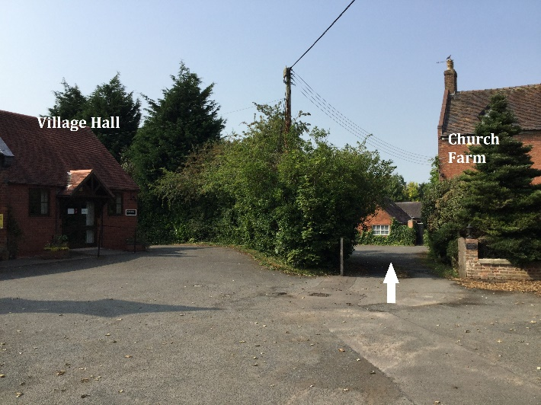
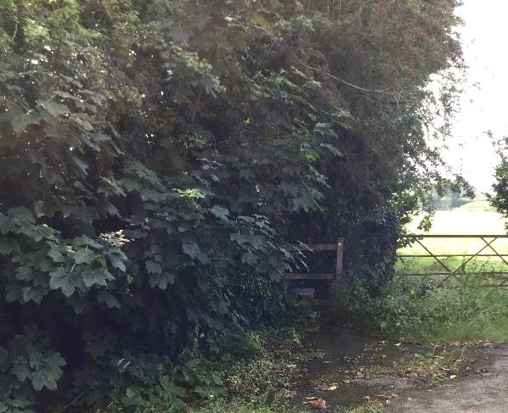
1. 2.
A word of warning to those walkers with shorter legs: this stile is a little higher than usual.
After crossing the stile, the walk turns right and proceeds along Bradley 0.1229. On the whole the path makes fairly easy walking. At the time of writing this account there were cattle in some of the fields along this path, but these were separated from the path by an electric fence. In those fields in which crops were planted there was adequate room left for walkers.
At the end of Bradley 0.1229 the path passes through a hedge to join up with Bradley 0.1228. However, the stile through which the walker must pass to reach Bradley 0.1228 is partly concealed as shown by photograph no.3 (below, taken on or about 26/07/20):

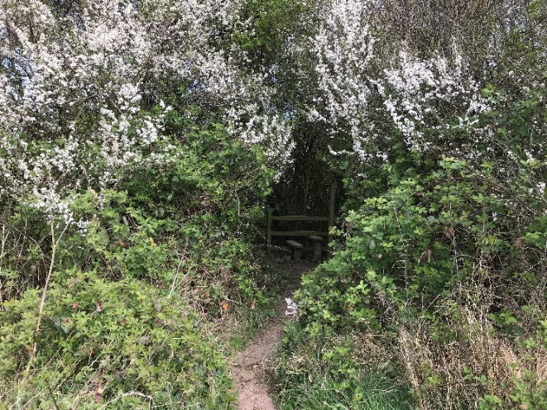
3.

Photograph no. 4 below (taken on or about 26/07/20), looks back to the stile after it has been crossed. There is no fingerpost to indicate the position of Bradley 0.1228.
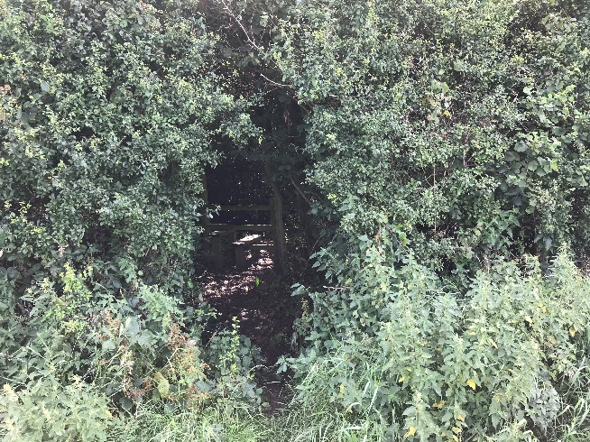
4.

As may be seen from the Staffs County Council map provided for this walk, with the walker’s back to the above stile, Bradley 0.1228 passes diagonally (to the left) over an open field. However, in preparation for the introduction of livestock, an electric fence has been placed around its perimeter. Consequently, in order to avoid interaction with the livestock, walkers should follow the diversion which lies around the perimeter of the field. It is marked in pink on the Google Earth image. This detour provides adequate space for walking between the electric fence and the hedge. Walkers then exit this field to join up with Bradley 0.1228 in the adjacent field, where this path continues on ahead with the hedge, which is punctuated by a row of trees, to the right.

This walk continues on Bradley 0.1228 until it reaches a gate in the hedge which stands next to a telegraph pole. See photograph no.5 below:
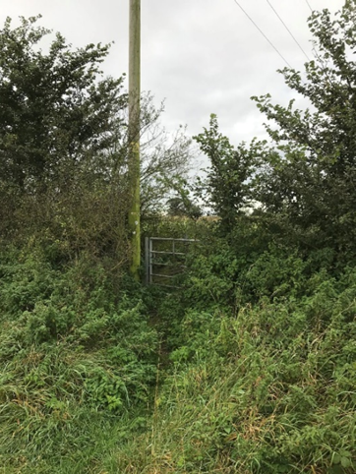
5.

After passing through this gate the walk continues forward towards Alstone Farm, as shown in photograph no. 6 below:
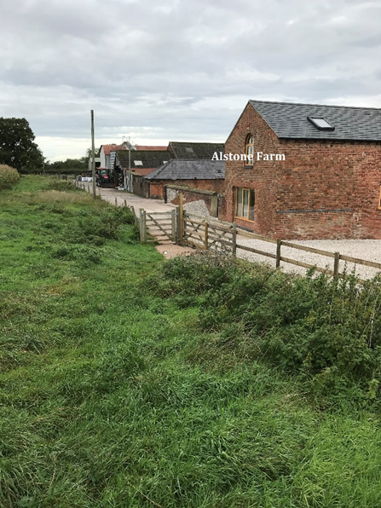
6.

After passing through the gate seen in the above photograph the walk continues onwards along the track which runs along the side of the farm buildings. This track opens out on to Alstone Lane, where the walk takes a left turn. Walk 8 then follows Alstone Lane to its junction with Barton Lane where it turns left. On reaching the top of Barton Lane another left turn takes the walk back to its starting point at the Village Hall.

